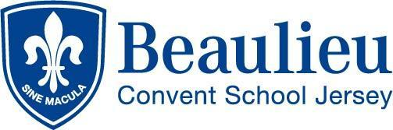

Person Specification

We seek to appoint a Teacher of Italian - Head of Subject responsibilities (with Spanish or French)

Who has:

- A suitable degree in Italian would be preferable or in French or Spanish
- Qualified Teacher status
- Proven track record of successfully teaching Italian at KS3 and KS4
- Up-to-date knowledge of curriculum developments
- Good communication skills
- Good ICT skills

Who is:

- An inspiring teacher
- A reliable, well-organised, successful classroom practitioner
- Committed to the ethos and values of a Catholic School
- Passionate about his/her subject, and able to share that enthusiasm with others
- Committed to personal development
- Seeking to become an outstanding teacher
- Able to innovate and deliver an inclusive curriculum
- To provide additional support lessons for the less able students to enhance their achievement

Who enjoys:

- An active academic life
- Engaging and motivating young people in the study of Modern Foreign Languages
- Working with young people in activities and disciplines outside the classroom to build up the school community

